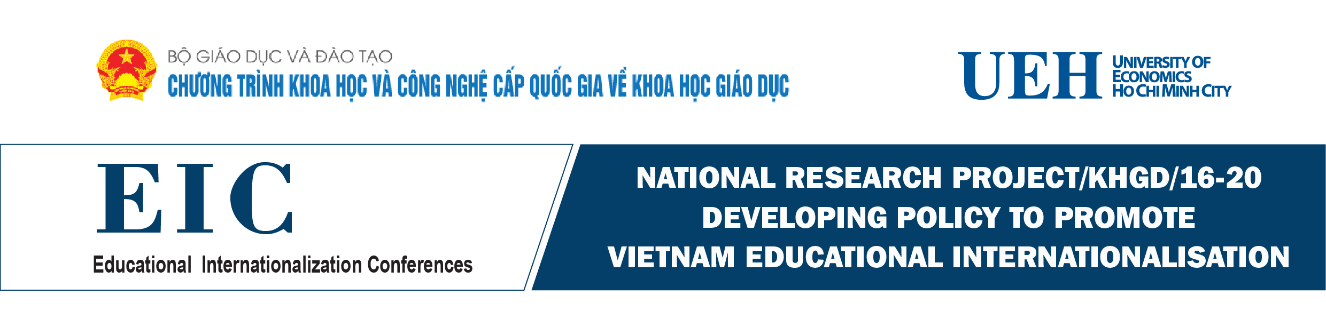

**INTERNATIONAL CONFERENCE**

***“Internationalising Education: The Role of Governments and Educational Institutions in Promoting Internationalisation of Education”***

***Date and Time: 8:00 - 12:30 on Friday 9th November 2018***

***Conference Hall: A.103 - University of Economics Ho Chi Minh City***

The Conference is actively hosted by UEH in collaboration with the National Program of Science and Technology on Education Science from the Ministry of Education and Training in Vietnam. The Conference is a platform for educational leaders, researchers and practitioners to discuss on international and regional education issues and challenges, and to discuss collaborative solutions and policy to promote educational internationalization in the context of Globalisation and Industrial Revolution 4.0. The Conference is including five sub-themes:

1. Policies to promote student mobility;

2. Policies to promote academic exchange and research;

3. Policies and programs at national level to promote transnational education under the form of direct training through setting up the campus in the foreign countries, applying MOOC, and joint programs…;

4. Policies to promote Internationalisation at home;

5. Policies to promote Internationalisation through effective institutional management.

The thematic conference provides opportunities to focus and discuss on specific areas from their own educational system and national experiences and the Conference will be vital to further promote internationalization among the countries. In addition there will be opportunities to meet and network with your strategic university partners and colleagues from this field and to share your experiences and to learn from others.

The tentative Progamme of the International Conference is to be attached here. Agenda_IECs_9.Nov.2018.docx

Board of Organizers